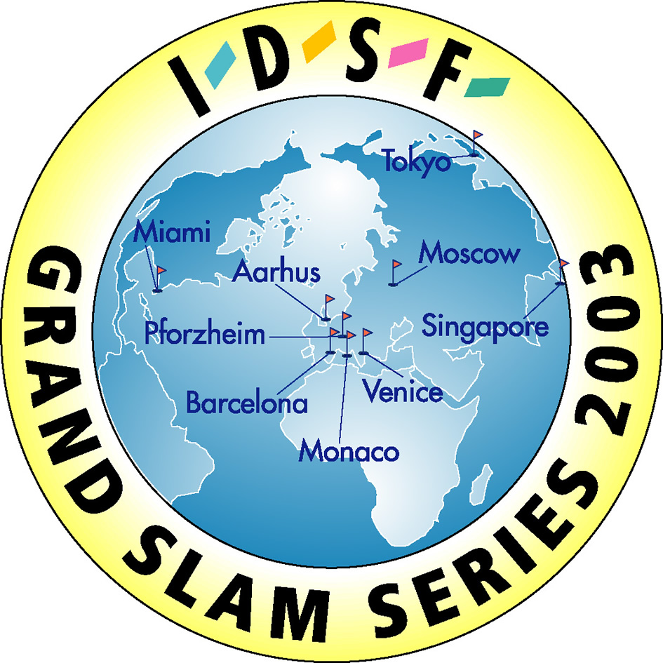

International DanceSport Federation
DanceSport Federation of Russia
Moscow Dance Sport Federation

PRESENT
IDSF GRAND SLAM Standard

To All IDSF National Member Federations

IDSF Grand Slam Standard on April 08, 2007

Ladies and Gentlemen,

We are pleased in accordance with the IDSF Competition Rules to invite couples from your nation to take part in IDSF Grand Slam Standard on April 08, 2007. Special prize money will be paid by IDSF.

Expenses in accordance with IDSF Competition Rule 8.
Minimum additional reimbursement for couples paid by the organizer for competitions in Europe:
- couples from 1st to 6th place will be paid 500 Euro;
- couples of the semi final which are not in the final will be paid 300 Euro.
Minimum additional reimbursement for couples from oversea paid by the organizer for competitions outside Europe or for couples from oversea participating in Europe:
- couples from1st to 6th place will be reimbursed for 3 nights hotel with breakfast plus 600 Euro;
- Couples of the semi final which are not in the final will be reimbursed for 3 nights hotel with breakfast or 300 Euro.

This event will be organized by the Executive Committee of Moscow DanceSport Federation, and will take place at the ‘Druzhba’ Sport Hall in Moscow. Time schedule will be informed later.
Hotel reservation for competitors and accompanying persons should be done until March 10, 2007 to Moscow Dance Sport Federation: Phone: (..7) 495 179 64 63 Fax: (..7) 495 178 70 80, E-mail: info@moscowdance.ru
In case of later reservation the Organizer does not guarantee the same room rate & the same hotel.
Hotel reservation for accompanying persons and reservation of additional nights for couples should be done until March 10, 2007 to Executive Board of Moscow Dance Sport Federation Phone: +7- 495 179 64 63 Fax: +7-495-178 70 80, E-mail: info@moscowdance.ru.

For Visa confirmation each coming person must send a scanned copy of passport, name of the suitable town in your country with Russian consulate to get VISA and address of occupation office until March 10, 2007 to the following e-mail: artburointer@bk.ru or fax number: +7 495 694 10 44/45.
All visa expenses in Russian Embassy or Consulate in your country must be paid by competitors and accompanying persons respectively.
The attached entry form must be returned directly to the Organizer - Executive Committee of Moscow DanceSport Federation, by March 10, 2007
Phone/Fax: +7-495 – 179 64 63 or 178 70 80. E-mail: info@moscowdance.ru .
We are looking forward to welcoming your couples in Moscow.

With best regards,
President
DanceSport Federation of Russia
Pavel Dorokhov

Entry form

Idsf GRAND SLAM STANDARD

08 APRIL 2007

Moscow
Country/IDSF Member____________________________________________________________________

Couple
- Male partner :
First NAme (like in passport) _____________________________________________________

FAMILY NAME (like in passport)____________________________________________________

Date of Birth __________________________________________________________

Passport # ________________________

DATE OF ISSUE______________________

Expiring date______________________

sitizenship ________________________

e-mail, fax _____________________________________________________________

- Female partner
First NAme (like in passport) _____________________________________________________

FAMILY NAME (like in passport) ____________________________________________________

Date of Birth __________________________________________________________

Passport # ________________________

DATE OF ISSUE______________________

Expiring date______________________

sitizenship ________________________

e-mail, fax _____________________________________________________________

Accompanying persons
First NAme (like in passport) _____________________________________________________

FAMILY NAME (like in passport) ____________________________________________________

Date of Birth ___________________________________________________________

Passport # ________________________

DATE OF ISSUE______________________

Expiring date_______________________

sitizenship ________________________

e-mail, fax _____________________________________________________________

Signature _______________________ date ___________________

