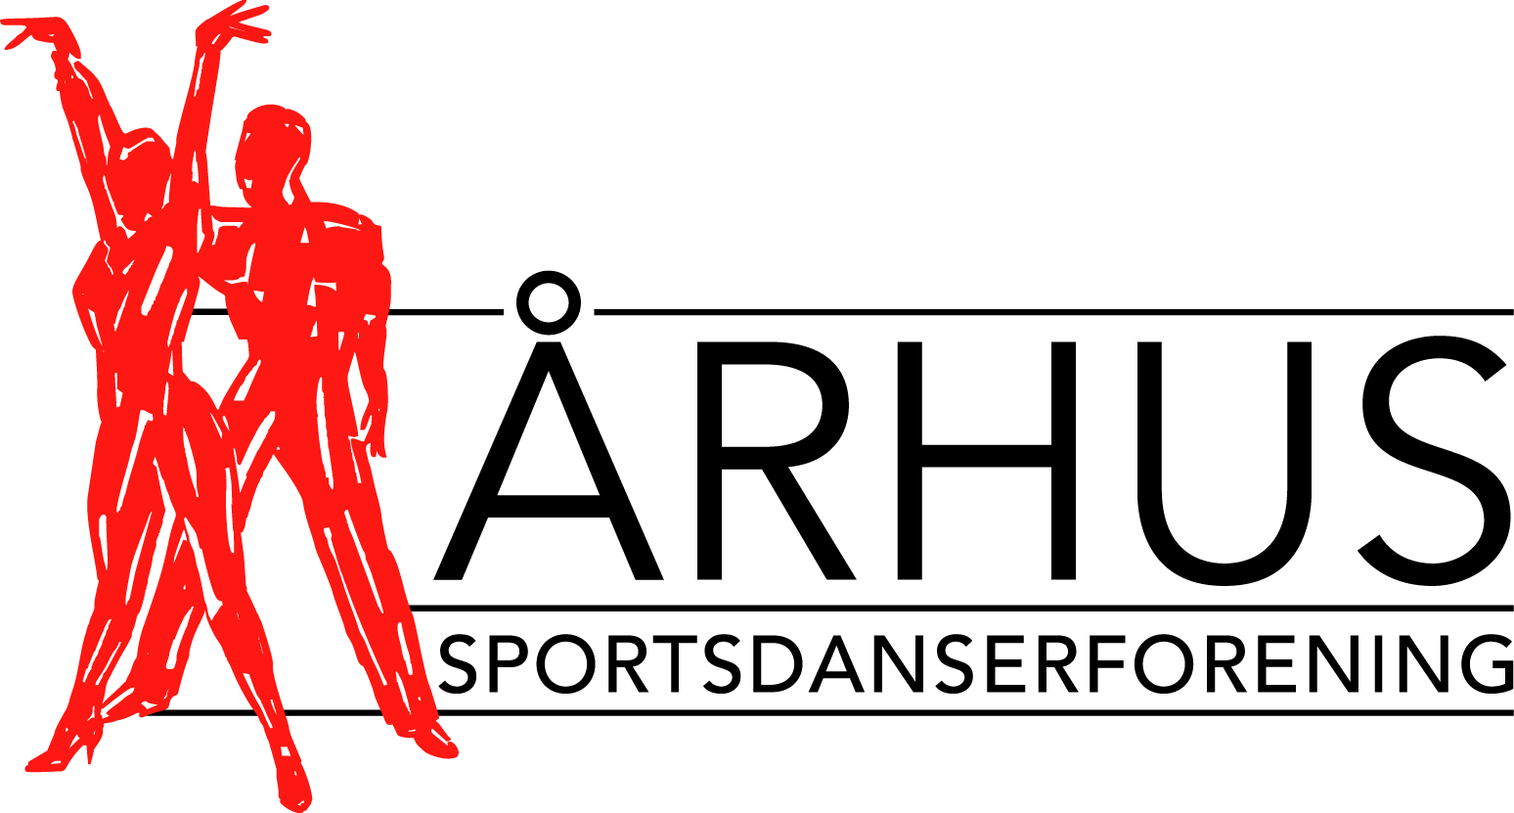

Århus Sportsdanserforening - Member of Danish Dance Sport Federation and IDSF – proudly presents
The 10th annual

Aarhus International Galla 2007

Including IDSF European Latin and IDSF International Open Standard

Aarhus International Galla has through its 10 successful years become one of the most significant events and dance competitions in Europe.

Date: Saturday 14th of April 2007.

Starts at 10.00 (approx) and with Gala evening from 19.00

Competitions: IDSF European Latin, IDSF International Open Standard and Youth Latin

Venue: NRGi Arena, Atletion, Stadion Allé 70, DK-8000 Aarhus C, Denmark

Adjudicators: A highly distinguished panel of adjudicators from at least 9 different countries approved by the IDSF

Prize money: A total sum of EURO 5.000

TV Coverage: TV coverage of the Gala evening Saturday

Age rules: According to IDSF regulations

Dress rules: According to IDSF regulations

Entry: E-mail to Jette Bager – jb@aarhusdans.dk – Telephone +4586332005/+4522787655 Entries must be received no later than 20th of March 2007

Entryfee: Euro 35 (DKK 250) pr. couple. Has to be on our account in Nordea Bank latest 1st of April 2007. Account number: 2211-6266 840 452 – IBAN: DK6720006266840452 – SWIFT: NDEADKKK. Please remember to state your name in the text field, in order to identify your payment!

Timetable: Will be published on our website one week prior to the event. All competitors have free access to the hall all day and evening.

Hotel: Check our website from 1st of March for attractive possibilities

For further information please visit www.aarhusdans.dk or www.em-latin.dk - or contact Jette Bager, e-mail: jb@aarhusdans.dk, phone: +452278 7655, or Sports Director Henrik Larsen, e-mail: hla@aarhusdans.dk, phone/fax:+45 8614 1808,mobile:+45 4063 3528.

We look forward to seeing you in Aarhus!

Other practical information for Aarhus International Galla

Transportation: Århus Sportsdanserforening provides regular bus transportation between official hotels and NRGi Arena on the competition day.

Flight and
Train connections: Direct international flight connections to Aarhus Tirstrup Airport (www.arhusairport.dk) with Ryan Air from London, with Sun Air/British Airways from Oslo, Stockholm and Gothenburg, and domestic flights several times per day from Copenhagen Airport. Regular bus connections are available from the airport to Aarhus. You may also take the train from Copenhagen Airport to Aarhus City Centre (approx. 3.5 hours).

Direct flight connections to Billund Airport (www.billund-airport.dk - approx. 1 hours drive from Aarhus:) from e.g. Amsterdam, Bergen, Dublin, Düsseldorf, Frankfurt, Frankfurt Hahn, Helsinki, London, Manchester, München, Oslo, Paris, Pisa, Prag and Stockholm. Regular bus connections are available from the airport to Aarhus City Centre

Social events: Saturday night after the International Gala, Århus Sportsdanserforening hosts a nice banquet for competitors, officials and special guests - and you should definitely not miss our famous After Party for all competitors taking place in a down town discotheque in Aarhus!

For further information please visit www.aarhusdans.dk or www.em-latin.dk
Or contact Jette Bager, e-mail: jb@aarhusdans.dk, phone: +452278 7655, or
Sports Director Henrik Larsen,e-mail: hla@aarhusdans.dk, phone/fax:+45 8614 1808,mobile:+45 4063 3528.

We look forward to seeing you in Aarhus!

