IDSF OPEN LATIN

& OPEN STANDARD COMPETITION

'' Ritam Open 2007 ''
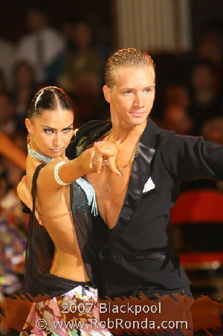
Saturday, 10 November, 2007
Hall '' Nenad Baštinac '' Aleksandrovac

11 international adjudicators from 7 countries
entry fee per day per couple 25 eur ( IDSF open ), 20 eur ( open ), 15 eur ( basic ), 8 eur ( D clase )

closing date, 07 November 2007
please send your entries by e-mail: master018@ptt.yu ;
ssveto@spinter.net
09.00 check in
10.00 the begining

*check in at least 60 minutes before 1 round
*couples from basic category ( only 5 dances ) can also take part in open competition

Prize money for IDSF open LA I - 400 EUR II - 300 EUR III - 200 EUR IV - 100 EUR V - 50 EUR VI - 50 EUR

CONTACTS AND INFORMATION
e-mail ssveto@spinter.net
Dance club ‘’ Ritam ‘’ Tel 00 387 51 740 008
Srbac, Bosnia And Herzegovina Fax 00 387 51 740 833

Mrs. Viktorija Savanović mob. 00 387 65 353 773
Mr. Branko Savanović mob. 00 387 65 925 860

Hotel accommodation with breakfast costs:
Hotel - 22 Euro per person per day

