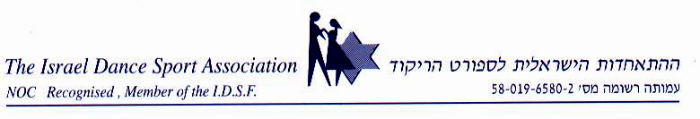
ENTRY FORM

10TH INTERNATIONAL DANCE SPORT CHAMPIONSHIPS “ASHDOD-2007”
8-9 DECEMBER 2007, ASHDOD (ISRAEL)

COUNTRY

Couple

1. MALE PARTNER:
FIRST NAME
FAMILY NAME
DATE OF BIRTH
CITIZENSHIP E-MAIL, FAX

2. FEMALE PARTNER
FIRST NAME
FAMILY NAME
DATE OF BIRTH
CITIZENSHIP
E-MAIL, FAX

3. DISCIPLINE: IDSF INTERNATIONAL OPEN LATIN -9.12.2007 ( )
IDSF OPEN STANDAND -8.12.2007 ( )

3. ACCOMPANYING PERSONS
FIRST NAME
FAMILY NAME
E-MAIL, FAX

ARRIVAL (DATE, TIME, FLIGHT NUMBER)

DEPARTURE (DATE, TIME, FLIGHT NUMBER)

SIGNATURE _______________________ DATE ___________________

