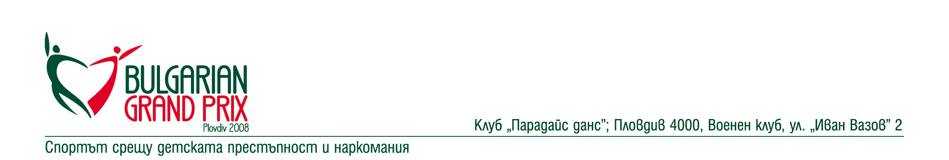
Dear Friends,
The Bulgarian Dance Sport Federation, the Municipality of Plovdiv and Dance Sport Club PARADISE DANCE have the pleasure to invite you to

BULGARIAN GRAND PRIX
www.bulgariangrandprix.com Plovdiv 2008

IDSF International Open Standard

&

IDSF Open Latin

Dates: 01-02 March 2008

Place of the event: Plovdiv, International Fair - Hall №10 http://www.plovdivcityguide.com/

Dancing Categories:
Category | 01 March 2008 | 02 March 2008
Basic program Juvenile I | Latin (Ch, R, J) | Standard (W, T, Q)
Basic program Juvenile II | Standard (W, T, Q) | Latin (Ch, R, J)
Basic program Junior I | Standard (W, T, VW, Q) | Latin (S, Ch, R, J)
Basic program Junior II | Latin (S, Ch, R, J) | Standard (W, T, VW, Q)
Basic program Over 16 | Standard (W, T, VW, Q) | Latin (S, Ch, R, J)
Open Juvenile | Latin (S, Ch, R, J) | Standard (W, T, VW, Q)
Open Junior I | Standard | Latin
Open Junior II | Latin | Standard
Open Youth | Standard | Latin
IDSF International Open | Standard
IDSF Open |  | Latin

Judgment: 13 adjudicators from thirteen countries nominated from organizer, confirmed by IDSF

Dress: IDSF rules must be applied

Starting Fee (per couple/day):
Category | One Program | Both Programs
Juveniles | EUR 15 | EUR 20
Juniors, Youth and Adults | EUR 20 | EUR 30

Prize money for Amateur IDSF World Ranking Tournaments:
Position | IDSF Int. Open Standard | IDSF Open Latin
1st place | EUR 1200 | EUR 500
2nd place | EUR 900 | EUR 400
3rd place | EUR 600 | EUR 300
4th place | EUR 400 | EUR 200
5th place | EUR 300 | EUR 150
6th place | EUR 200 | EUR 100
Total: | EUR 3600 | EUR 1650

For all finalists in Juvenile, Junior and Youth – cups, diplomas and beautiful presents

For more information, online entry, accommodation, contact with the organizers please see:
http://www.bulgariangrandprix.com/

Welcome and
Best regards,
Svetozar Zhekov
Director of BULGARIAN GRAND PRIX

